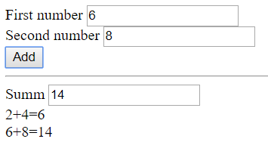
<!DOCTYPE html>
<html lang="en">

<head>
<meta charset="UTF-8">
<meta name="viewport" content="width=device-width, initial-scale=1.0">
<meta http-equiv="X-UA-Compatible" content="ie=edge">
<title>Document</title>
</head>

<body>
<label>
First number
<input type="text" name="" id="a1" value="0"/>
</label> <br>
<label>
Second number
<input type="text" name="" id="a2" value="0"/>
</label> <br>
<button id="myBtn">
Add
</button>
<hr>
<label>
Summ
<input type="text" name="" id="sum" value="0"/>
</label> <br>
<div id="container">

</div>
<script>
function myBtnClick() {
const inp1=document.getElementById('a1')
let firstNumber=parseInt(inp1.value)

const inp2=document.getElementById('a2')
let secondNumber=parseInt(inp2.value)

let sum=firstNumber+secondNumber

const resSum=document.getElementById('sum')
resSum.value=sum
//--------------
const container=document.getElementById('container')
// container.innerHTML+=`<div>${firstNumber}+${secondNumber}=${sum} </div>`
const div=document.createElement('div') //Створили новий div
div.innerText=`${firstNumber}+${secondNumber}=${sum}` //Додали текст
container.appendChild(div) //Вставлии div у кінець container

}
const btn=document.getElementById('myBtn')
btn.onclick=myBtnClick

</script>
</body>

</html>

